FOR IMMEDIATE RELEASE

Veteran and Cincinnati Resident Lends a Helping Hand in Kenya as Part of
Freedom Alliance Inaugural Mission Trip
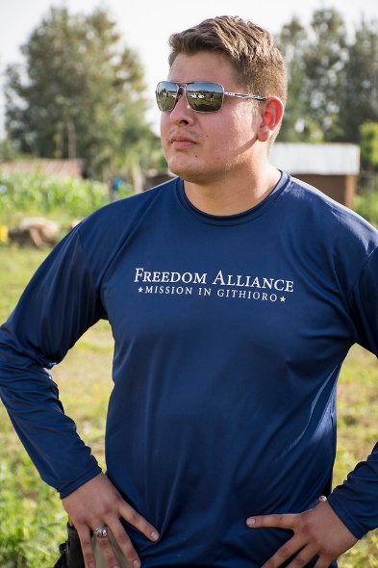
CINCINNATI, Ohio – (June 28, 2016) – Marine and Cincinnati resident, Cpl. Anthony Watson, recently participated in an international mission trip to Kenya in the village of Githioro, north of Nairobi. The journey was hosted by Freedom Alliance, an organization that supports our nation’s service members and their families. Watson is a partially disabled veteran who served two deployments to Iraq. He was one of five combat veterans from across the country who attended the inaugural trip from June 10 - 19.

"There wasn't a moment when I didn't feel genuine humility. I’m very grateful for the opportunity to make a difference in Githioro, develop relationships and partner with other people to provide both physical and spiritual support,” Watson commented.

The group went to assist Neighbors Outreach Worldwide (N.O.W), a charity focused on finding sponsors for Kenyan children to attend Holy Trinity Private School – which gives them a chance to break out of poverty. The organization is helping with the construction of a domestic violence shelter for women in the area, and the Freedom Alliance team helped build a shed for a new water source and ministered to the male workers looking to find work at the construction site.
Marine Cpl. Anthony Watson enjoys the scenery on a safari as part of a Freedom Alliance mission trip to Kenya.

“This was an opportunity to make a life-changing impact on some men who’ve sacrificed much for our country,” said Pepper Ailor, Director of Programs for Freedom Alliance. “We saw cultural barriers overcome, and emotional walls break down,” he continued. “They have returned with new friendships, a strengthened and renewed faith in God, and a greater appreciation for what we have in the United States.”

The trip concluded with a two-night stay and safari (not hunting) in the Maasai Mara National Reserve. Watson and the other veterans got to see wildlife, such as lions, zebra, and antelope, while riding in open-top vans.

Photos of the trip may be found here: http://photos.freedomalliance.org/SupportOurTroopsProgram/2016/2016-06-21-Mission-in-Githioro/.

For media inquiries, please contact Althea Paul of Vistra Communications at 813.321.3310 or AltheaP@ConsultVistra.com.

About Freedom Alliance
Freedom Alliance is a charitable organization which provides help and support to wounded troops and military families. Freedom Alliance has awarded more than $10 million in college scholarships to the children of military heroes killed or disabled in military service and spent millions more helping injured veterans and military families with outdoor recreational therapy trips, Heroes Vacations, care packages for deployed troops, mortgage-free homes, all-terrain wheel chairs and much more. You can learn more about Freedom Alliance at www.FreedomAlliance.org.
###

