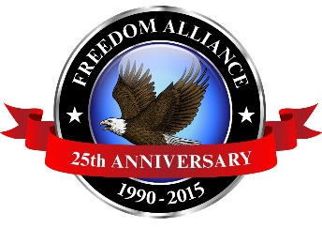
Media Contact:
Donnie Gallagher
DonnieG@ConsultVistra.com
Main: 813.961.4700
Direct: 813.321.3314

FOR IMMEDIATE RELEASE

Army Veteran, Amputee Set to Receive
Customized Wheelchair in Las Vegas

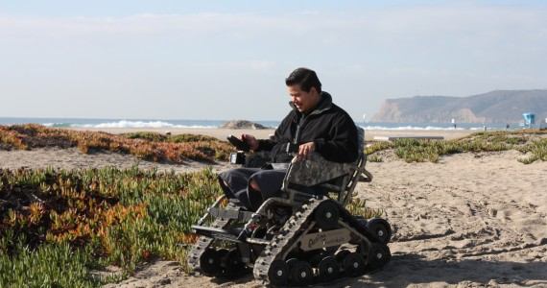
Freedom Alliance, an organization supporting our nation’s injured service members, is set to donate a customized, all-terrain wheelchair to an Army veteran. The Action TrackChair will be given to Las Vegas resident Spc. Blaine Sullivan at the Santa Fe Station Hotel & Casino on Saturday, Aug. 5 at 6 p.m. This is the thirteenth chair Freedom Alliance has donated to a deserving veteran this year. This event is open to the public.

Sullivan served in the Army for two years before his career ended abruptly after losing his leg to an improvised explosive device (IED) blast in Afghanistan. He was awarded a Purple Heart award for his injury.
He currently receives ongoing treatment at Walter Reed National Military Medical Center in Maryland.
Previous TrackcChair donation recipient USMC Cpl. Carlos Garcia demos his chair during the December 2013 presentation in California.

Sullivan is looking forward to the new chair as it will help ease the transition into civilian life and back to his favorite hobbies including hunting, fishing and off-road racing. The functionality of the chair will allow Sullivan the mobility desired when spending time with his family which includes his wife, Kristyn and their two young children.

Previous Trackchair donation information found at: https://freedomalliance.org/highlights/marine-amputee-receives-all-terrain-trackchair\.

Media should RSVP to Donnie Gallagher of Vistra Communications by phone at 813.321.3314 or by email to DonnieG@ConsultVistra.com.

About Freedom Alliance
Freedom Alliance is a charitable organization which provides help and support to wounded troops and military families. In addition to Trackchair donations, Freedom Alliance has awarded more than $9 million in college scholarships to the children of military heroes who were killed or disabled in military service. The organization has also spent millions more to help injured service members and military families with outdoor recreational therapy, Heroes Vacations, care packages for deployed troops, mortgage-free homes and much more. You can learn more about Freedom Alliance at www.FreedomAlliance.org.
###

