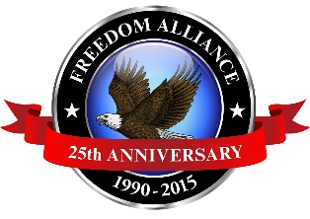
Media Contact:
Donnie Gallagher
Vistra Communications
813.961.4700, ext. 208
DonnieG@ConsultVistra.com

For Immediate Release
MEDIA ADVISORY

Freedom Alliance Continues Tradition of Appreciation Dinner for Injured
Service Members at Fort Riley

WHAT: For the eighth year in a row, Freedom Alliance is set to host up to 60 injured service members recovering at the Warrior Transition Battalion in Fort Riley, Kansas along with their families to a dinner at Umi Japanese Steakhouse.
WHEN: The dinner will be held on Wednesday, Dec. 2 at 6 p.m. This event is not open to the public.

WHO: The dinners recognize America’s injured service members for their sacrifice to our country and provide an opportunity for them and their families to enjoy a relaxing evening in a quality restaurant, with a group of their peers and support group members.
WHERE: Umi Japanese Steakhouse located at 900 Hayes Dr., Manhattan, KS 66502.

WHY: The Troop Appreciation Dinners are held in fine restaurants across the country, several times a year, as one way to ensure those injured service members and their families know they are not forgotten.

Freedom Alliance also sponsors lunches, vacations, family fun days, weekend outings and other events to benefit our nation’s heroes. To learn more visit www.FreedomAlliance.org.

Media interested in attending should contact Donnie Gallagher of Vistra Communications at DonnieG@ConsultVistra.com or 813.961.4700 ext. 208.

About Freedom Alliance
Celebrating its 25th anniversary in 2015, Freedom Alliance is a charitable organization which provides help and support to wounded troops and military families. Freedom Alliance has awarded more than $9 million in college scholarships to the children of military heroes killed or disabled in military service and spent millions more helping injured veterans and military families with outdoor recreational therapy trips, Heroes Vacations, care packages for deployed troops, mortgage-free homes, all-terrain wheel chairs and much more. You can learn more about Freedom Alliance at www.FreedomAlliance.org.

###

