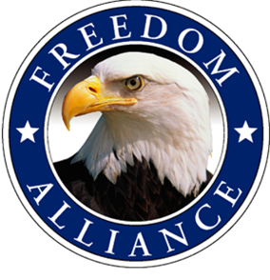
Media Contact:
Althea Paul
Vistra Communications
813.961.4700, ext. 204
AltheaP@ConsultVistra.com

FOR IMMEDIATE RELEASE

Freedom Alliance Helps Restore Enterprise Military Family with
Faith-Based, Caribbean Cruise

ENTERPRISE, Ala. – (July 11, 2016) – Master Sgt. Pedro San-Miguel, his wife and their two young children recently enjoyed a family retreat to the Caribbean, sponsored by Freedom Alliance. This faith-based cruise gave the family an opportunity to heal from the wounds of war. San-Miguel medically retired in 2014 from the U.S. Army after 22 years of service and currently suffers from post–traumatic stress.

Freedom Alliance, a charitable organization that supports our nation’s injured service members, hosted the San-Miguels, along with two other deserving military families on the annual Michael W. Smith & Friends Caribbean Cruise, July 2-9. This marked the third year Freedom Alliance has participated in the faith-based cruise, which helps to strengthen military families whose relationships are strained by long military deployments to dangerous combat areas and run the risk of divorce.

“The goal of this retreat was to help keep military marriages and families together, and we’re grateful we gave the San-Miguels and others a chance to re-connect emotionally and spiritually with their loved ones,” said Tom Kilgannon, president of Freedom Alliance.

With stops including St. Maarten and Puerto Rico, the Christian-based cruise included daily live worship music, bible teaching and engaging family-oriented fun. Michael W. Smith is a Grammy Award winning and multi-Platinum selling contemporary Christian singer/songwriter.

Since the start of the program in 2007, Freedom Alliance has hosted more than 50 families on getaway retreats to locations including Alaska, Disneyland and Hawaii among others.

For media inquiries, please contact Althea Paul of Vistra Communications at 813.321.3310 or AltheaP@ConsultVistra.com.
About Freedom Alliance
Freedom Alliance is a charitable organization which provides help and support to wounded troops and military families. Freedom Alliance has awarded more than $10 million in college scholarships to the children of military heroes killed or disabled in military service and spent millions more helping injured veterans and military families with outdoor recreational therapy trips, Heroes Vacations, care packages for deployed troops, mortgage-free homes, all-terrain wheel chairs and much more. You can learn more about Freedom Alliance at www.FreedomAlliance.org.
###

