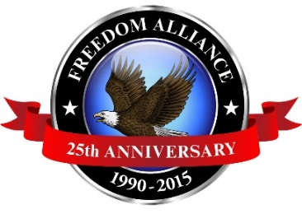
Media Contact: Donnie Gallagher
DonnieG@ConsultVistra.com
Main: 813.961.4700
Direct: 813.321.3314

FOR IMMEDIATE RELEASE

Freedom Alliance Honoring 16 Injured Service Members
With Costa Rican Vacation April 13-18

Fort Worth resident and wounded veteran participating in week-long tropical adventure
Fort Worth, Texas – (April 13, 2015) – Retired USMC corporal and Fort Worth resident Mike Fox is set for a Heroes Vacation from Freedom Alliance, a nonprofit organization that supports wounded troops and military families. As one of 16 injured service members from across the country, Fox will participate in this all-expenses paid trip designed to assist in recovery from combat-related injuries. The trip is scheduled for April 13-18 at the Los Sueños Resort and Marina in Costa Rica.
Fox lost both legs when he stepped on an improvised explosive device in November 2011 while serving in Afghanistan.
“We look forward to the upcoming Heroes Vacation in Costa Rica. This is just a small way to show appreciation to our service members for their bravery and sacrifice,” said Tom Kilgannon, president of Freedom Alliance. “These vacations allow injured troops to build healing relationships and enjoy time away.”
Los Sueños encompasses a private 600-acre rainforest reserve, an 18-hole championship golf course, full-service marina, spa and more. The trip will feature a crocodile safari and a zip line canopy tour, as well as a golf clinic and deep sea fishing.
The Heroes Vacation is made possible from generous sponsors and donors including: Los Sueños Resort and Marina; Jose’s Crocodile River Tour; the Vista Los Sueños Zip Line Canopy Tour; Gerald & Virginia Lindholm; Jose Quesada, PGA Director of Golf at La Iguana Golf Course; Larry Allison Jr; Lee Anderson, API Group; Bob Burnside; Bob & Judy Yanover; Ron Rule; Randy Cook; as well as the numerous individual donors who contributed to the cost of the service members’ travel expenses and luxury condo stay.
About Freedom Alliance
Celebrating its 25th anniversary in 2015, Freedom Alliance is a charitable organization which provides help and support to wounded troops and military families. Freedom Alliance has awarded more than $9 million in college scholarships to the children of military heroes killed or disabled in military service and spent millions more helping injured veterans and military families with outdoor recreational therapy trips, Heroes Vacations, care packages for deployed troops, mortgage-free homes, all-terrain wheel chairs and much more. You can learn more about Freedom Alliance at www.FreedomAlliance.org.
###

