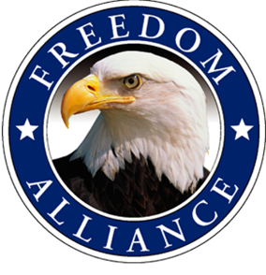
Media Contact:
Althea Paul
Vistra Communications
813.961.4700, ext. 204
AltheaP@ConsultVistra.com

FOR IMMEDIATE RELEASE

Freedom Alliance Honoring Local Injured Service Member with Adventurous Outdoor Costa Rican Vacation

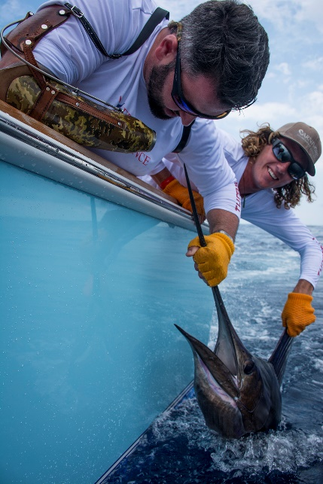
Smith Station, Ala. – (April 19, 2016) – Medically retired United States Army corporal and Smith Station resident, Josh McCart, was recently apart of a Heroes Vacation. McCart lost his right hand while serving in Iraq in 2007, when an improvised explosive device detonated. Freedom Alliance, a nonprofit organization that supports injured service members and their families, hosted this all-expense-paid trip for McCart and 15 other veterans from across the country. The fourth annual adventure took place April 11-16 at the Los Sueños Resort and Marina in Costa Rica was designed to assist in the veterans’ recovery from combat-related injuries.

This once-in-a-lifetime trip provided not only a week of fun and relaxation, but also an opportunity to bond and build healing relationships. “It is an honor and a privilege to provide Heroes Vacations as a way to thank injured service members who have sacrificed so much, and a responsibility we take very seriously,” said Tom Kilgannon, president of Freedom Alliance. “These brave men have seen the worst of conditions while fighting for our country. Now, they deserve to enjoy some of the best experiences.”
Medically retired United States Army corporal and Smith Station resident, Josh McCart, enjoys fishing in Costa Rica as part of Freedom Alliance’s annual Heroes Vacation.

Los Sueños encompasses a private 600-acre rainforest reserve, an 18-hole championship golf course, full-service marina, spa and more. The trip will feature a crocodile safari and a zip line canopy tour, as well as a golf clinic and deep sea fishing.

The Heroes Vacation is made possible from generous sponsors and donors, including Freedom Alliance Board Member Gerald Lindholm and his wife Virginia, Los Sueños Resort and Marina, the many condo and yacht owners that make these activities possible, Gato Gordo Golf Cart Rentals, Wiley X, Inc., PGA Director of Golf at La Iguana Golf Course Jose Quesada, Jose’s Crocodile River Tour, the Vista Los Sueños Zip Line Canopy Tour and Tunaskin Aquatic Apparel.
About Freedom Alliance
Freedom Alliance is a charitable organization which provides help and support to wounded troops and military families. Freedom Alliance has awarded more than $10 million in college scholarships to the children of military heroes killed or disabled in military service and spent millions more helping injured veterans and military families with outdoor recreational therapy trips, Heroes Vacations, care packages for deployed troops, mortgage-free homes, all-terrain wheel chairs and much more. You can learn more about Freedom Alliance at www.FreedomAlliance.org.

###

