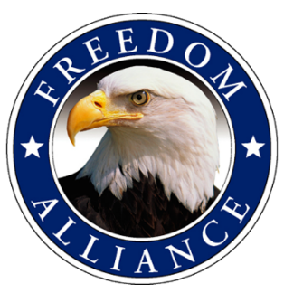
Media Contact:
Althea Paul
Vistra Communications
813.961.4700, ext. 204
AltheaP@ConsultVistra.com

MEDIA ADVISORY

Freedom Alliance Hosts Military Appreciation Care Package Drive
at Chick-fil-A Locations in D.C. Area

What: As part of Military Appreciation Month, Freedom Alliance has partnered with local Chick-fil-A locations to sponsor a care package drive to support our military heroes. Providing simple but necessary items like snacks, and basic toiletry items lets service members know they are in our thoughts. Requested items include: snacks, blank note cards, Keurig cups, coffee beans, creamer, sugar, straws, laundry pods, sunscreen, warm knit hats, protein bars, DVD’s, magazines, baby wipes, lotion and chap stick. (No soft chocolate. Liquids should be in Ziploc bags.). All items must be packed in a large flat rate shipping box. Participants receive coupon for Free Chick-fil-A Sandwich upon dropping off a full box.

When: May 16 – 31 during restaurant business hours, Monday - Saturday, 6 a.m. - 10 p.m.

Where: Chick-fil-A Dulles Town Crossing located at 45440 Dulles Crossing Plz, Sterling, VA
Chick-fil-A George Washington located at 44835 Lakeview Overlook Plz, Ashburn, VA.

Why: May is Military Appreciation Month, which allows for many opportunities to thank service members for the sacrifices they’ve made for our grateful nation.

For more information about the drive, please contact Lindsay Davis at 703.723.6172.

**Media interested in covering the care package drive should contact Althea Paul of Vistra Communications at AltheaP@ConsultVistra.com or 813.961.4700.

About Freedom Alliance
Freedom Alliance is a charitable organization which provides help and support to wounded troops and military families. Freedom Alliance has awarded more than $10 million in college scholarships to the children of military heroes killed or disabled in military service and spent millions more helping injured veterans and military families with outdoor recreational therapy trips, Heroes Vacations, care packages for deployed troops, mortgage-free homes, all-terrain wheel chairs and much more. You can learn more about Freedom Alliance at www.FreedomAlliance.org.
###

