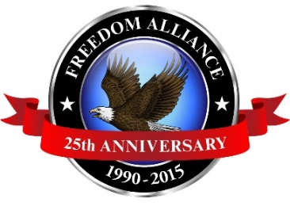
Media Contact: Donnie Gallagher
DonnieG@ConsultVistra.com
Main: 813.961.4700
Direct: 813.321.3314

FOR IMMEDIATE RELEASE

Injured Military Veterans Strengthened by Alaskan
Fishing Trip

SITKA, Alaska – (May 27, 2015) – Freedom Alliance, a charitable organization that supports our nation’s injured service members, hosted an exclusive saltwater Alaskan fishing excursion May 19-23 for 11 deserving soldiers from across the country. The second annual adventure is one of the many outdoor rehabilitation activities held throughout the year to support our heroes. In attendance were veterans diagnosed with post-traumatic stress disorder, traumatic brain injuries, as well as other combat-related physical injuries.

“These memorable outdoor trips are a great recreational experience for our veterans. The men have risked their lives for our country and we are proud to honor their service with the beauty of the great outdoors,” said Tom Kilgannon, president of Freedom Alliance.

Upon arrival to Alaska, the servicemen were greeted by the Alaskan Coast Guard. Home to many species of fish, the state has an abundance of freshwater streams, rivers and lakes. Past Freedom Alliance anglers have caught halibut, salmon and rockfish.

The trip was made possible through generous support from organizations and individuals. Vonnie's Fishing Guide Service & Bed and Breakfast donated the four-day, three-night expedition, as well as all of the gear, tackle and bait. Additional sponsors included: Blue Charters, Sitka Point Charters, IslandView Resort & Charters and Elk’s Lodge #1662.

Photos from the trip can be found at: http://bit.ly/1FYlANg

For media inquiries please contact Donnie Gallagher of Vistra Communications at 813.321.3314 or DonnieG@ConsultVistra.com.
About Freedom Alliance
Celebrating its 25th anniversary in 2015, Freedom Alliance is a charitable organization which provides help and support to wounded troops and military families. Freedom Alliance has awarded more than $9 million in college scholarships to the children of military heroes killed or disabled in military service and spent millions more helping injured veterans and military families with outdoor recreational therapy trips, Heroes Vacations, care packages for deployed troops, mortgage-free homes, all-terrain wheel chairs and much more. You can learn more about Freedom Alliance at www.FreedomAlliance.org.
###

