IMMEDIATE RELEASE October 18, 2014
Phone: 813.321.3314 Contact: Donnie Gallagher
Fax: 813.961.4702 Donnieg@ConsultVistra.com

Injured Service Members Gear Up for Exhilarating, Four-Day
Rogue River Fishing Trip

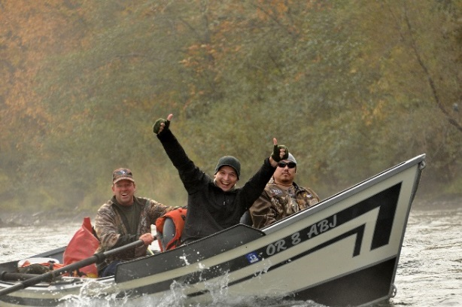
Portland, Ore. – October 18, 2014 –
Freedom Alliance, which supports America’s military, will host 11 injured service members, including Portland resident Josh Sherwood (USMC), on an annual four-day fishing excursion. The group will travel down 65 miles of the action-packed Rogue River in Grants Pass, Oregon. The trip offers the chance to experience nature and fish for steelhead trout, salmon and other native fish in one of our country’s most historic rivers. The troops arrive in Oregon on Oct. 18 for an expedition they are sure to remember.
These proud veterans live with a number of injuries including post-traumatic stress and outdoor adventures such as this one enable injured veterans the opportunity to share their wartime experience and build camaraderie, which promotes healing.

“This provides recreational therapy for these wounded heroes who deserve the best,” said Tom Kilgannon, President of Freedom Alliance. “Given that they were deployed to war-torn corners of the globe, they deserve to visit one of the most beautiful and relaxing places there is – Grants Pass and the Rogue River. Freedom Alliance organizes this annual trip to honor our nation’s military and their service. It also allows them to once again enjoy the outdoors in spite of their injuries.”

Freedom Alliance has hosted similar events for injured troops on the Rogue River for the last three years. The organization also coordinates dozens of such events each year for injured service members, along with Heroes Vacations for military families and other activities.

The expedition is guided by Bret Clark of Briggs Rogue River Trips, who has led whitewater trips for more than 35 years. The Rogue is one of eight rivers in the United States to be cited in the 1968 “Wild and Scenic Rivers Act,” which allows the river to be preserved in free-flowing condition. This event is not open to the public.
About Freedom Alliance
Freedom Alliance is charitable organization which honors and supports military service. In addition to their work with wounded service members, Freedom Alliance has provided more than $8 million in college scholarships to the children of military heroes who’ve been killed or disabled in a combat mission or training exercise. Visit www.FreedomAlliance.org.
###

