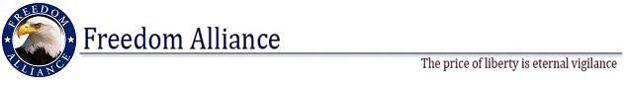

FOR IMMEDIATE RELEASE July 27, 2012
Phone: 813.961.4700 Contact: Kendra Cummings
Fax: 813.961.4702 Kendra@ConsultVistra.com

North Central Area High Students Graduates from Freedom Alliance Leadership Academy
Cadets Madison and Tristen Harper Attends Military Leadership Camp
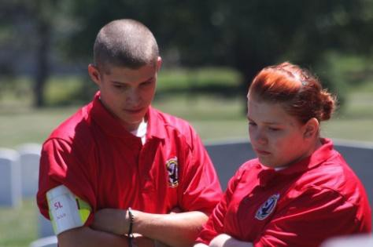

(Dulles, VA) – Carney residents and local high school students, Madison and Tristen Harper, have successfully completed the Freedom Alliance Military Leadership Academy, held June 17- 30 at Ft. Indiantown Gap, Pennsylvania. The academy provides high school students an opportunity to examine military lifestyle and culture while gaining valuable leadership experiences. Since 2001, the Freedom Alliance Military Leadership Academy has been dedicated to transforming young men and women into well-rounded leaders. Many graduates, among other accomplishments, have gone on to serve as officers or enlisted personnel or enroll in an ROTC program.
“The past two weeks were exhausting and strenuous, but Cadets Madison and Tristen Harper exceeded our expectations,” said Director of Programs, Pepper Ailor. “Their determination to our mission was unmatched. We are proud to have shared the MLA experience with them, and wish them the best of luck in the future.”
Cadets participated in the two-week program based on the curriculum of the U.S. Army. Physical training, tours of military bases, leadership simulations, land navigation, field tactics, urban warfare training, and a visit to Washington, D.C. are a few of the many activities included at the Academy.

The Academy has positively impacted the lives of over 1,000 students by infusing them with a sense of patriotism and a great respect for the military. Graduates go on to become better leaders in their school, career, and community.

For more information please visit www.MLAcamp.com or www.FreedomAlliance.org.

To view more photos of Cadets Madison and Tristen Harper please visit a Flickr account at http://www.flickr.com/photos/83374499@N08/ or type “VistraTampa” in the search box.
About Freedom Alliance

Freedom Alliance is recognized by the Internal Revenue Service (IRS) as a public charity organized under Section 501(c)(3) of the IRS Code. The mission of Freedom Alliance is to advance the American heritage of freedom by honoring and encouraging military service, defending the sovereignty of the United States and promoting a strong national defense. Visit www.FreedomAlliance.org.

###

