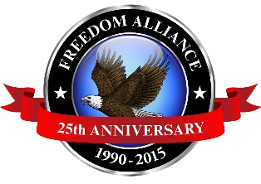
Media Contact:
Kendra Cummings
Vistra Communications
813.961.4700 Ext. 206
DonnieG@ConsultVistra.com

For Immediate Release
MEDIA ADVISORY

Organizations Partner to Provide Annual Holiday Meal to
Service Members at the USO in Atlanta

What: For the ninth year in a row, Freedom Alliance and the United Services Organization (USO) of Georgia will join forces to provide our nation’s troops with a delicious holiday meal from Williamson Bros. Bar-B-Q Restaurant. The lunch includes a spread of ham, turkey, and dressing as well as other traditional holiday sides. Freedom Alliance will also distribute gift bags, which includes a special message to the troops transiting through the airport for the holidays.

When: Monday, Dec. 14 from 11 a.m. - 2 p.m.
Where: Hartsfield-Jackson Atlanta International Airport
Jean R. Amos USO Center
Suite 320
6000 Terminal Parkway
Why: These meals are a small way to show appreciation and gratitude to our service members and their families. We are grateful to be a part of creating holiday moments for deserving men and women of our armed forces.

USO of Georgia is operated by the USO Council of Georgia, Inc. and assists more than 400,000 individuals annually; making it one of the largest USO operations in the world. Permanent staff and volunteers help provide the services.

**Media interested in covering should contact Kendra Cummings of Vistra Communications at Kendra@ConsultVistra.com or 813.961.4700 Ext. 206.

Celebrating its 25th anniversary in 2015, Freedom Alliance is a charitable organization which provides help and support to wounded troops and military families. Freedom Alliance has awarded more than $10 million in college scholarships to the children of military heroes killed or disabled in military service and spent millions more helping injured veterans and military families with outdoor recreational therapy trips, Heroes Vacations, care packages for deployed troops, mortgage-free homes, all-terrain wheel chairs and much more. You can learn more about Freedom Alliance at www.FreedomAlliance.org.
###

