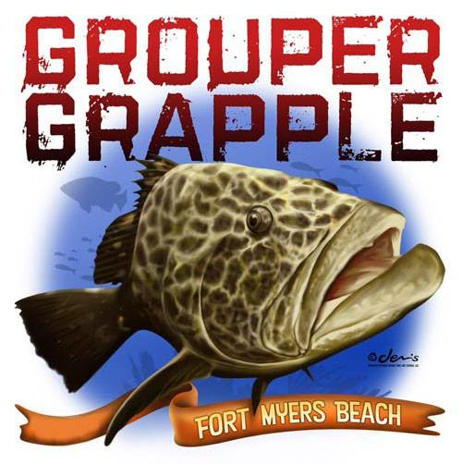
FOR IMMEDIATE RELEASE

Contact: Donnie Gallagher
Vistra Communications
Phone 813.321.3314
DonnieG@ConsultVistra.com

Second Annual Grouper Grapple Offshore Fishing Tournament to Benefit Injured Service Members
Fort Myers Beach, Fla. - August 8, 2014: The Second Annual Grouper Grapple Offshore Fishing Tournament is being held August 14-15 at the Fish Tale Marina on Fort Myers Beach. The Grouper Grapple officials established the tournament as a means to raise awareness for two organizations, Marine Corps Association Foundation Wounded Marine Support Program and Freedom Alliance. Both organizations serve our Military Heroes both physically and mentally. This event is open to the public.
In 2013, more than 250 people enjoyed food, fun, live music and caught the teams’ weigh-in action at the First Annual Grouper Grapple Offshore Fishing Tournament. There were 17 fishing teams (91 anglers) with the winning anglers receiving a payout of $13,000, and a check for $3,000 was presented to the Marine Corps Association Foundation. This year, the Grouper Grapple Tournament officials hope to exceed the purse and the donation amount, encouraging businesses and anglers to get involved to show our Military Heroes how much their service is appreciated.
In addition to the offshore fishing tournament that hosts both single engine and twin engine divisions, the Grouper Grapple will provide a group of Military Heroes a day of freedom and fun on the water. Each Hero will receive: air fare, hotel accommodations, a night out to dinner, day fishing on the Back Bay with a seasoned local captain, and entry to the Grouper Grapple party including dinner. There are several levels of sponsorship opportunities available and the registration can be viewed and completed online at www.groupergrapple.com.
Please visit www.groupergrapple.com for more information or contact Brian Peachey at info@groupergrapple.com.
About Freedom Alliance
Freedom Alliance is recognized by the Internal Revenue Service (IRS) as a public charity organized under Section 501(c)(3) of the IRS Code. The mission of Freedom Alliance is to advance the American heritage of freedom by honoring and encouraging military service, defending the sovereignty of the United States and promoting a strong national defense. For more information, visit www.FreedomAlliance.org.
About Marine Corps Association Foundation Wounded Marine Support Program
​Challenging and serving Marines who have been severely injured or emotionally and mentally scarred is a critical and growing Marine Corps Association and Foundation focus. Our work with the Wounded Warrior Regiment supports “Survive to Thrive” Marines in keeping them thinking like Marines — instead of sinking into the doldrums of just being a patient — during their rehabilitation. Through these efforts, individuals are more likely to return faster to where they want to be — serving again in regular Corps assignments and advancing their careers. www.mcafdn.org
###

