***MEDIA ADVISORY***

World Record Holder to Pull Chick-fil-A Truck to Raise Money for Freedom Alliance

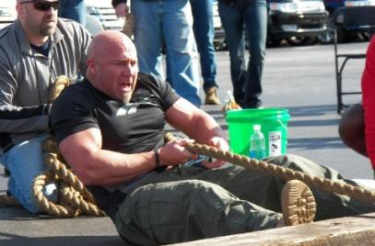
For more information, contact: Kendra Cummings
Vistra Communications 813.961.4700
Kendra@ConsultVistra.com

WHAT: Three-time world record holder Greg Cochran of The Fitness Forum will pull a Chick-fil-A truck for 15 minutes as part of a fundraiser. Pledges will be made per pull and will benefit Freedom Alliance. The personal trainer has set 3 world records: most 50 foot truck pulls in one hour while sitting for a 5,300-pound truck and 6,000-pound truck, and most tire flips using a 550-pound tire in one hour. All funds raised from his world records have gone to charity.

WHEN: Saturday, Sept. 8, 2012 at 8 a.m.

WHERE: The truck pull is an event at the Chick-fil-A 5k race, which starts and finishes at the Chick-fil- A at Dulles Crossing: 45440 Dulles Crossing Plz, Sterling, VA 20166. This event provides a great photo opportunity.

Chick-fil-A will provide post race food for runners. Come out and race the Chick-fil-A cows!

About Freedom Alliance
Freedom Alliance is recognized by the Internal Revenue Service (IRS) as a public charity organized under Section 501(c)(3) of the IRS Code. The mission of Freedom Alliance is to advance the American heritage of freedom by honoring and encouraging military service, defending the sovereignty of the United States and promoting a strong national defense. To learn more about Freedom Alliance or our Scholarship Fund, please visit FAScholarship.com. You may also call 800.475.6620.

###

