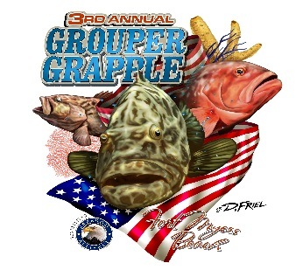
Contact: Donnie Gallagher
Vistra Communications
Phone: 813.321.3314
DonnieG@ConsultVistra.com
FOR IMMEDIATE RELEASE
Benefit for Injured Service Members Lures Anglers to Offshore
Fishing Tournament

FORT MYERS BEACH, Fla. – (Aug. 4, 2015) – More than 100 anglers are expected to cast a line for the third annual Grouper Grapple Offshore Fishing Tournament benefiting injured service members August 14 and 15 at the Fish Tale Marina located at 7225 Estero Blvd. One hundred percent of the contributions raised from the two-day event benefit Freedom Alliance, an organization supporting injured service members and their families. This event is open to the public.
“We are incredibly thankful to the organizers and sponsors of this year’s Grouper Grapple Offshore Fishing Tournament,” said President of Freedom Alliance, Tom Kilgannon. “The generosity of everyone involved reminds our veterans that we are not only thankful for their service to our country, but also the sacrifices made by their families.”
Coordinators and participants in last year’s tournament raised $5,000 in donations for Freedom Alliance and hosted eight veterans by covering their airfare, hotel accommodations, a night out to dinner, a fishing excursion and entry to both the Grouper Grapple tournament and the after-party dinner. These eight veteran ‘alumni’ along with eight additional veterans will be in attendance to join the festivities.
In 2014, more than 500 people enjoyed food, fun and live music while catching the 24 fishing teams’ weigh-in action. Winning crews received combined winnings of more than $12,000, as well as an additional $2,600 in Calcutta payouts. This year, tournament officials hope to exceed both the purse and amounts donated by encouraging businesses and anglers to get involved to show military heroes how much their service is appreciated. Several levels of sponsorship opportunities are available and registration can be viewed and completed online at www.groupergrapple.com or by contacting Brian Peachey at info@groupergrapple.com.
Interested media should contact Donnie Gallagher at DonnieG@ConsultVistra.com or 813.321.3314.
About Freedom Alliance
Celebrating its 25th anniversary in 2015, Freedom Alliance is a charitable organization which provides help and support to wounded troops and military families. Freedom Alliance has awarded more than $9 million in college scholarships to the children of military heroes killed or disabled in military service and spent millions more helping injured veterans and military families with outdoor recreational therapy trips, Heroes Vacations, care packages for deployed troops, mortgage-free homes, all-terrain wheel chairs and much more. You can learn more about Freedom Alliance at www.FreedomAlliance.org.
###

