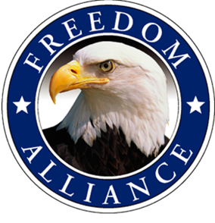
Media Contact:
Althea Paul
Vistra Communications
813.961.4700, ext. 204
AltheaP@ConsultVistra.com

FOR IMMEDIATE RELEASE
Freedom Alliance Helps Local Injured
Service Member Heal with Annual Alaskan Voyage

COLORADO SPRINGS, Colo. – (May 09, 2016) – Colorado Springs resident and medically retired United States Army Staff Sgt. Aaron Kim is set to participate in an annual Alaskan fishing excursion. Kim was injured by an improvised explosive device while serving in Afghanistan. Freedom Alliance, a charitable organization that supports our nation’s injured service members, will host the exclusive saltwater Alaskan fishing excursion May 13 - 17 for 16 deserving soldiers from across the country. The third annual adventure is one of the many outdoor rehabilitation activities held throughout the year to support our nation’s heroes.

Home to many species of fish, the state has an abundance of freshwater streams, rivers and lakes. Past Freedom Alliance anglers have caught halibut, salmon and rockfish. Sitka’s position near the Pacific Ocean makes it an ideal location to catch up to five types of delicious salmon. Its natural splendor not only creates a delightful and relaxing experience, but also provides much-needed healing and reprieve to inured service members.

“It has been a privilege and a pleasure to support these brave men and women over the years. We owe a large debt of gratitude for all the sacrifices made by those in our armed forces and these outdoor trips are just a small way we say thank you,” said Tom Kilgannon, president of Freedom Alliance.

The trip was made possible through generous support from organizations and individuals. Vonnie's Fishing Guide Service & Bed and Breakfast donated the four-day, three-night expedition, as well as all of the gear, tackle and bait. Additional sponsors include: Blue Charters, IslandView Resort & Charters and Elk’s Lodge #1662.

For media inquiries, please contact Althea Paul of Vistra Communications at 813.321.3310 or AltheaP@ConsultVistra.com.
About Freedom Alliance
Freedom Alliance is a charitable organization which provides help and support to wounded troops and military families. Freedom Alliance has awarded more than $10 million in college scholarships to the children of military heroes killed or disabled in military service and spent millions more helping injured veterans and military families with outdoor recreational therapy trips, Heroes Vacations, care packages for deployed troops, mortgage-free homes, all-terrain wheel chairs and much more. You can learn more about Freedom Alliance at www.FreedomAlliance.org.

###

