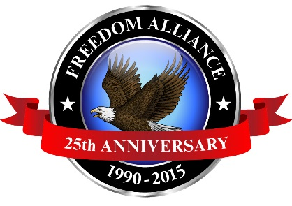
Media Contact: Donnie Gallagher
DonnieG@ConsultVistra.com
Main: 813.961.4700
Direct: 813.321.3314

NOT FOR IMMEDIATE RELEASE
Freedom Alliance Salutes Injured Veterans at Appreciation Dinner
FABENS, Texas – (April 6, 2015) – Freedom Alliance is honoring approximately 300 military families and injured service members from the Warrior Transition Battalion at Fort Bliss with a Troop Appreciation Dinner at Cattleman’s Steakhouse, Thursday, April 9 from 6 p.m. to 10 p.m. This event is not open to the public.
“The Troop Appreciation Dinners are an integral aspect of the healing process for our selfless, injured service members, “said Calvin Coolidge, executive director of Freedom Alliance. “These are small acts of appreciation for the men and women who sacrificially serve our country, but allow opportunities for building comradery, family bonding and a reprieve from their usual hospital routine.”
This is the fifth Troop Appreciation Dinner at Cattleman’s Steakhouse that Freedom Alliance has hosted for the injured servicemen and servicewomen near Fort Bliss.
Media interested in covering this event must contact Donnie Gallagher at 813.321.3314 or DonnieG@ConsultVistra.com.

About Freedom Alliance
Celebrating its 25th anniversary in 2015, Freedom Alliance is a charitable organization which provides help and support to wounded troops and military families. Freedom Alliance has awarded more than $9 million in college scholarships to the children of military heroes killed or disabled in military service and spent millions more helping injured veterans and military families with outdoor recreational therapy trips, Heroes Vacations, care packages for deployed troops, mortgage-free homes, all-terrain wheel chairs and much more. You can learn more about Freedom Alliance at www.FreedomAlliance.org.
###

