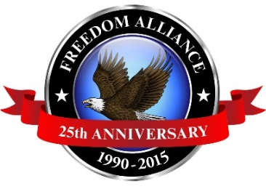
Media Contact: Donnie Gallagher
DonnieG@ConsultVistra.com
Main: 813.961.4700
Direct: 813.321.3314

MEDIA ADVISORY

Freedom Alliance Hosts Veteran Expedition Down the James River

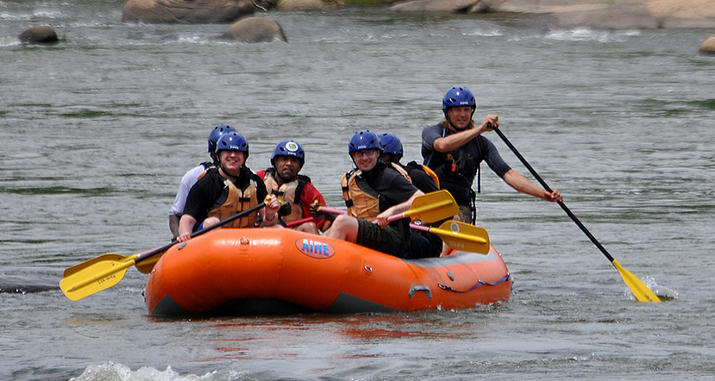
What: Freedom Alliance is hosting a white water rafting trip for a dozen injured service members from the Hunter Holmes McGuire VA Hospital in Richmond. The trip will offer an exciting change of scenery from their typical hospital setting. The adventure includes navigating the rapids of the James River, lunch on one of the river islands, and a view of the spectacular sights, as the servicemen take in the surrounding wildlife.

When: Thursday, May 21.
Where: The group will begin at Riverside Outfitters-6836 Old Westham Rd., Richmond, VA 23225.

Why: This white water trip will give this group of injured servicemen a reprieve from the medical surroundings they are used to, a fun-filled experience, and aid in their recovery efforts.

**Photos of this trip can be provided upon request. Interested media should contact Donnie Gallagher at DonnieG@ConsultVistra.com or 813.321.3314.

Interviews can be set up in advance. Photos from last year can be found here: http://bit.ly/1ILRRpI.

About Freedom Alliance
Celebrating its 25th anniversary in 2015, Freedom Alliance is a charitable organization which provides help and support to wounded troops and military families. Freedom Alliance has awarded more than $9 million in college scholarships to the children of military heroes killed or disabled in military service and spent millions more helping injured veterans and military families with outdoor recreational therapy trips, Heroes Vacations, care packages for deployed troops, mortgage-free homes, all-terrain wheel chairs and much more. You can learn more about Freedom Alliance at www.FreedomAlliance.org.

###

