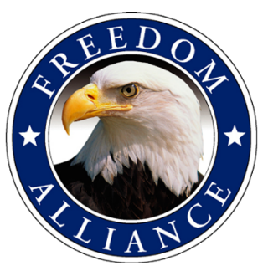
Media Contact:
Althea Paul
Vistra Communications
813.961.4700, ext. 204
AltheaP@ConsultVistra.com

FOR IMMEDIATE RELEASE

Local Injured Veteran Given Customized Wheelchair this Fourth of July
Weekend from Freedom Alliance

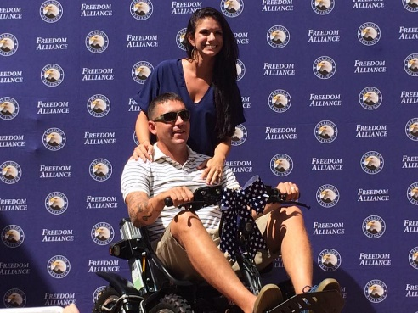
FORT MYERS, Fla. – (July 1, 2016) – Freedom Alliance, an organization supporting our nation’s injured military service members, recently presented a Zoom Ability Chair to Port Charlotte resident and U.S. Marine Corp (USMC) veteran, Sgt. Adam Ryder. He currently suffers from post-traumatic stress in addition to kidney disease and is 100 percent Veterans’ Administration (VA) disabled. The event took place at Vistra Communications’ (Vistra) offices located at 15436 N. Florida Ave. on Friday, July 1.

Ryder, who medically retired in 2014, served in the USMC for nearly 11 years and was deployed into military action four times. He is highly decorated, having received the Combat Action Ribbon, National Defense Service Medal and the Humanitarian Service Medal, among others. This electric chair will greatly assist Ryder with his mobility challenges.
U.S. Marine Corp veteran Sgt. Adam Ryder receives a new Zoom Ability Chair, alongside his wife Kathryn, from Freedom Alliance on July 1 in Tampa.

“Even though I don’t consider myself a hero, I appreciate this more than anyone will understand. This Zoom Chair will allow me to spend more quality time with my family,” said Sgt. Ryder. “I ask that during this holiday weekend, people remember those who matter the most, the service members who didn’t come back.”

Freedom Alliance has donated similar all-terrain chairs to nearly 20 injured service members to aid in their mobility and independence. Tom Kilgannon, President of Freedom Alliance, presented the Zoom Ability Chair to Sgt. Ryder. “I can’t think of a better way to kick off this Independence Day weekend. After all, our freedom is made possible because of service members such as Sgt. Ryder and many others who sacrifice life and limb for our country,” said Kilgannon.

Ryder lives with his wife and three young children.

View photos of the event here: http://photos.freedomalliance.org/SupportOurTroopsProgram/2016/2016-07-01-Zoom-Chair-Ryder/.

For media inquiries, please contact Althea Paul of Vistra Communications at 813.321.3310 or AltheaP@ConsultVistra.com.

About Freedom Alliance
Freedom Alliance is a charitable organization which provides help and support to wounded troops and military families. Freedom Alliance has awarded more than $10 million in college scholarships to the children of military heroes killed or disabled in military service and spent millions more helping injured veterans and military families with outdoor recreational therapy trips, Heroes Vacations, care packages for deployed troops, mortgage-free homes, all-terrain wheel chairs and much more. You can learn more about Freedom Alliance at www.FreedomAlliance.org.

###

