Media Contact: Donnie Gallagher
DonnieG@ConsultVistra.com
Main: 813.961.4700
Direct: 813.321.3314

FOR IMMEDIATE RELEASE

Military Veterans Set for Outdoor Expedition in White River National Forest

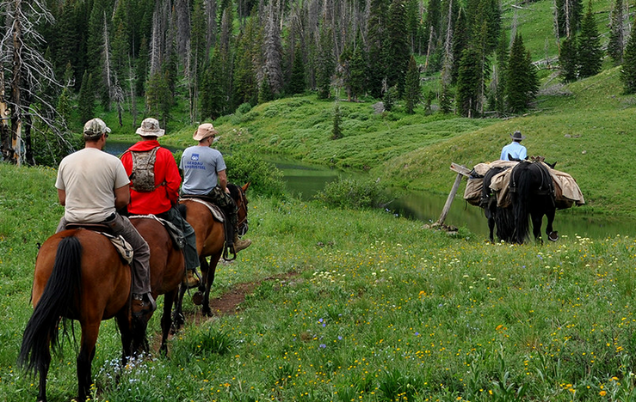
MEEKER, Colo. – (June 30, 2015) – Freedom Alliance is set to host four injured service members on an outdoor expedition through the scenic Flattop Mountains in the White River National Forest of Colorado. During the four-day journey starting on July 15, the group will enjoy a variety of outdoor activities including fishing and hiking-all which provide therapeutic recreation and help focus on life beyond injuries.

“These brave veterans deal with the effects of combat-related trauma every day,” said Tom Kilgannon, president of Freedom Alliance. “Outdoor adventures such as this provides them the opportunity to share their experiences and struggles, as well as build camaraderie, which promotes healing.”
Four men from 2014 outdoor trip participate in Equine Therapy in the White River National Forest.

The outdoor experience provides an escape and reprieve from the daily hospital scenery. “The past few days did more for me than the past two years of counseling,” said Dave, a Marine combat veteran who participated in a previous Freedom Alliance’s recreational therapy trip.

Flat Top Mountain is the highest summit of the Flat Tops in the Rocky Mountains of North America. The group will reside in canvas-walled tents at 9300 feet elevation near the Upper Marvine Lake, which offers a scenic view and several species of trout for fishing.

Freedom Alliance has partnered with Adams Lodge Outfitters for this unique outdoor expedition for the second year.

Freedom Alliance also sponsors vacations, family fun days, weekend outings and other events to benefit injured service members and their families. To learn more visit www.FreedomAlliance.org.

About Freedom Alliance
Celebrating its 25th anniversary in 2015, Freedom Alliance is a charitable organization which provides help and support to wounded troops and military families. Freedom Alliance has awarded more than $9 million in college scholarships to the children of military heroes killed or disabled in military service and spent millions more helping injured veterans and military families with outdoor recreational therapy trips, Heroes Vacations, care packages for deployed troops, mortgage-free homes, all-terrain wheel chairs and much more. You can learn more about Freedom Alliance at www.FreedomAlliance.org.
###

