Media Contact:
Donnie Gallagher
Vistra Communications
813.961.4700, ext. 208
DonnieG@ConsultVistra.com

Rogue River Fishing Trip for Wounded Service Members Set to Create Memories and Healing
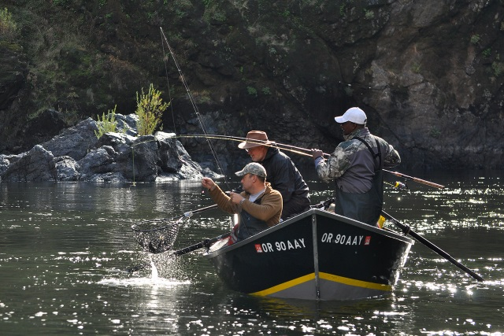
GRANTS PASS, Ore. – (Oct. 13, 2015) – Eleven wounded service members from across the country will soon experience the adventure of a lifetime. Freedom Alliance, a charitable organization that supports the military and their families, will host the combat veterans for its annual fishing excursion on the Rogue River. This group consists of four Vietnam veterans and seven Iraq and Afghanistan veterans. The trip runs from October 17-23.
During the annual trip in 2014, two injured service members vie for some of the best salmon and steelhead trout the Rogue has to offer.

The trip will kick off with a visit to Wildlife Images Rehabilitation and Education Center in Grants Pass including a tour of the facility and an up close and personal experience with animals including birds of prey, mammals, and reptiles. Afterward, the men will hit the Rogue for their excursion. The 65-mile river journey, which will launch from Almeda Park in Merlin, allows the veterans to experience the natural wonders of the Rogue River and enjoy activities such as fishing, swimming and simply taking in scenic landscape views along the river.
The majority of these veterans live with a number of injuries and conditions, including post-traumatic stress disorder and traumatic brain injuries. Outdoor adventures such as these enable them to share their wartime experience and build camaraderie, which promotes healing.

“Recreational therapy is so important for combat veterans. This allows them to enjoy outdoor activities once again, despite their traumas,” said Tom Kilgannon, President of Freedom Alliance. “After all they’ve sacrificed for this country, these veterans deserve an amazing experience that will also help in their continued recovery.”

Freedom Alliance has hosted similar events for injured troops on the Rogue River for the last four years. The organization also coordinates dozens of similar events each year for injured service members, along with Heroes Vacations for military families and other activities.

The expedition is guided by Bret Clark of Briggs Rogue River Trips, who has led whitewater trips for more than 35 years. The Rogue is one of eight rivers in the United States to be cited in the 1968 “Wild and Scenic Rivers Act,” which allows the river to be preserved in free-flowing condition. This event is not open to the public.

About Freedom Alliance
Celebrating its 25th anniversary in 2015, Freedom Alliance is a charitable organization which provides help and support to wounded troops and military families. Freedom Alliance has awarded more than $9 million in college scholarships to the children of military heroes killed or disabled in military service and spent millions more helping injured veterans and military families with outdoor recreational therapy trips, Heroes Vacations, care packages for deployed troops, mortgage-free homes, all-terrain wheel chairs and much more. You can learn more about Freedom Alliance at www.FreedomAlliance.org.

###

